

Reduced Fat Choc Chip Cookie, 2.0 oz, SKU# 70660
Reduced Fat Choc Chip Cookie, 2.0 oz, SKU# 70650
Reduced Fat Choc Chip Cookie Dough, 2.0 oz, SKU# 75640

Nutrition Facts | Total Fat 7 g 11% Total Carbohydrate 37 g 12%  Sat Fat 2 g 10% Fiber 1 g 4%  Trans fat 0 g Sugars 20 g  Cholesterol 0 mg 0% Protein 2 g  Sodium 200 mg 8%
Amt/Serving size; 2.0 oz
(57 grams)
Servings per container: 1
Calories 220
Calories from Fat 60
Vit A – 0% * Vit C – 0% * Calcium – 0% * Iron – 8%

Ingredients:

Enriched Flour (Wheat Flour, Malted Barley Flour, Niacin, Iron, Thiamin Mononitrate, Riboflavin, Folic Acid), Sugar, Chocolate Chips (Sugar, Chocolate Liquor, Cocoa Butter, Soy Lecithin (an emulsifier), Vanilla, salt), Shortening (Refined, Bleached and Deodorized Soybean Oil and Fully Hydrogenated Soybean Oil Blend with citric acid added as a preservative), Raisin Paste, Egg Replacer (Bleached enriched wheat flour (wheat flour, malted barley flour, Modified Food Starch (defatted soybean flour, dextrose, emulsifier, (mono and diglycerides, ethoxylated mono and Diglycerides, sugar, dried egg yolks, soybean oil, soybean lecithin, guar gum), Modified Food Starch, Baking Soda, Salt, Natural vanilla flavor (Glycerin, alcohol, water, sugar, natural flavors (including vanilla bean extractives), propylene glycol)

CONTAINS: Milk, Egg, SOY, WHEAT

Bread Servings: (57 X 0.35) 14.75 = 1.35 BreadS (rounds down to 1.25)

Breads | Fruit/Vegetable | Protein
1.25 | Na | Na

I certify that the above information is true and correct.
6/1/2011 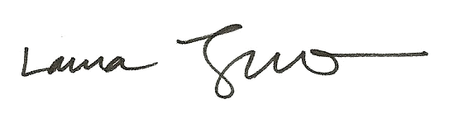
Date Laura Trujillo, RD, SNS

